Verification and Testing

|  |  |  |
| --- | --- | --- |
| Click - -> View Intro Video  Click - -> Download Solution |  | **Purpose:** |
|  |  | * A Test Plan is a grouping of Test Runs * A Test Run can be:   + Are assigned to „Tester“ and „Test Reviewer“   + Related to a Simulation and its results   + Defined Test Procedures with recorded results   + Run automated   + Run step by step manually with automated results recording   + Run step by step manually with manual results recording * Test Plan Templates * Optional Integration with Aras RE, SM, SA * Provide evidence that Requirements are satisfied by related Product Design * Evidences are the result of Test Runs. |

**Solution Facts:**

|  |  |
| --- | --- |
| Create Date: | December 2020 |
| Lastest Version Date: | December 2020 |
| Maturity Level: | Good for Reuse |
| Degree of Customization: | Medium |
| Solution Content: | [x] Package    [x] Code Tree Patch      [-] AML           [-] Sample Code |
| Solution Sample Data: | [] AML       [-] Package     [-] Batchloader [x] use Standard Demo DB |
| Impact on other Solutions: | [-] Modifies existing functionality       [-] Replaces existing functionality |
| Impact on Aras Platform: | [-] Modifies existing Service   [-] Replaces existing Service |

**Sources:**

|  |  |
| --- | --- |
| Originator: | Rolf Laudenbach |
| Credits: |  |
| Customer Project or POC: | Forrester Wave Dec 2020 Demo |

**Usage**

1. log on as "mmiller" ....

2. Go to TOC main level. Notice 1 new category "Verification and Testing"

3. Go to Administration/Identities and find new Identity "Verification and Testing". Add users to its members (i.e. Mike Miller)

4. log on as "mmiller"

5. Go to "Verification and Testing/Test Plans" create a new Test Plan, Test Runs, Test Procedures etc. ....

Create Test Plan Templates with set of Test Runs and Test Procedures and Owners (non-alias) assigned.

On creation of new Test plan a template can be referenced. On initial save the Test Runs from the template get added.

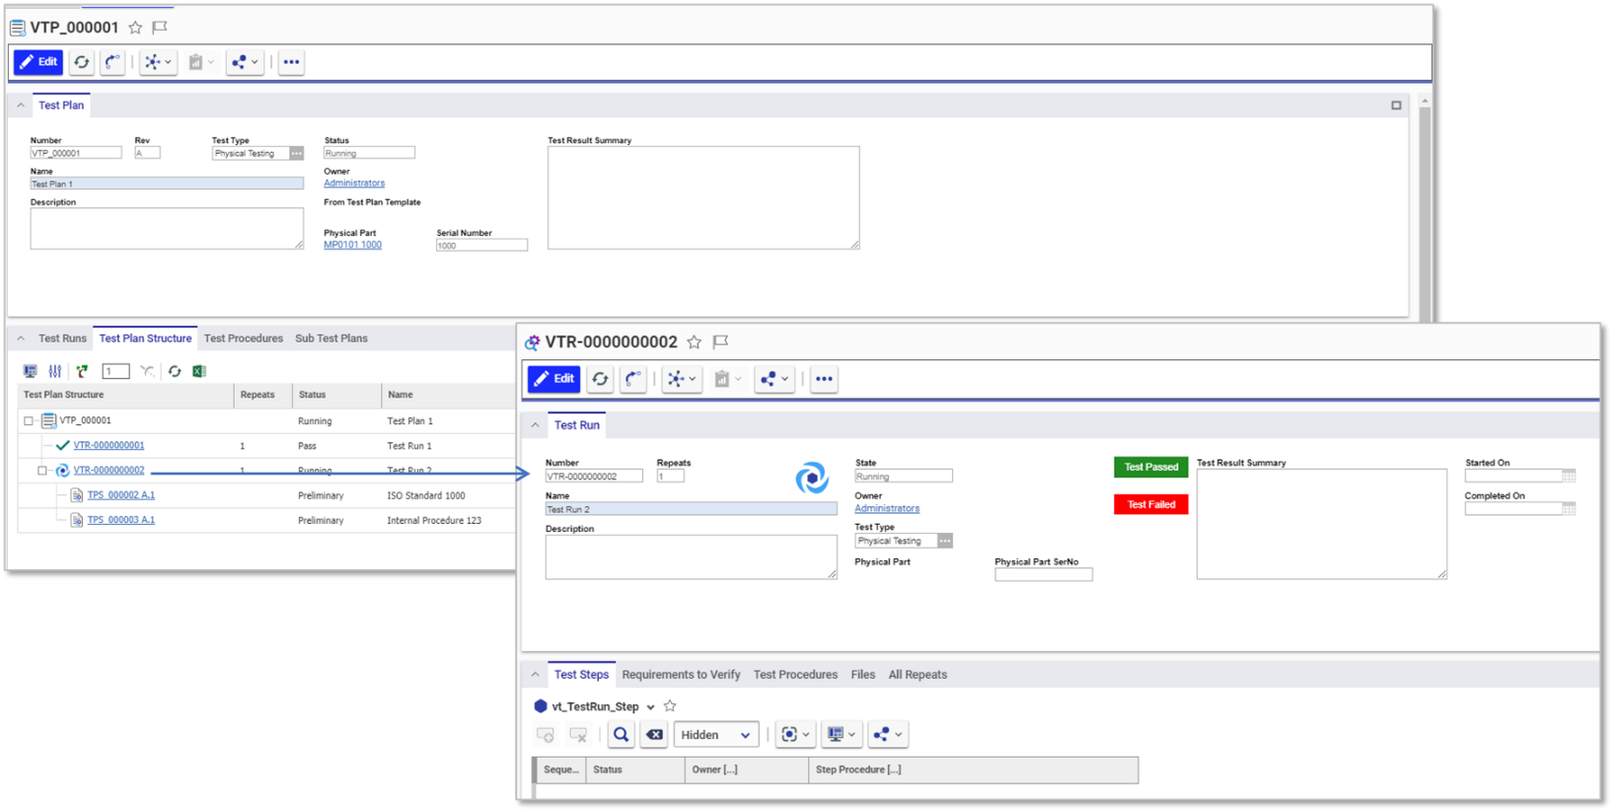

Test Runs are versioned. When in status “Pass” or “Fail” an new “Repeat of Run”, that will create a new version, can be started from the Test Plan by using right mouse click action “Re Run Test”

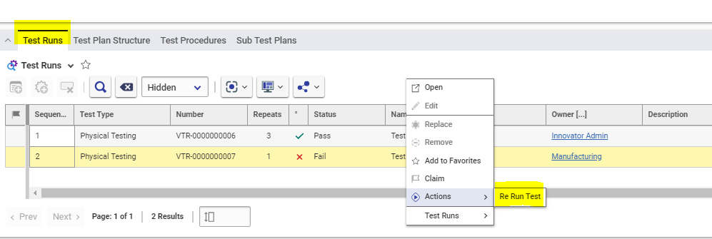

On Test Runs the full history of all “Repeats” (versions) can be viewed.

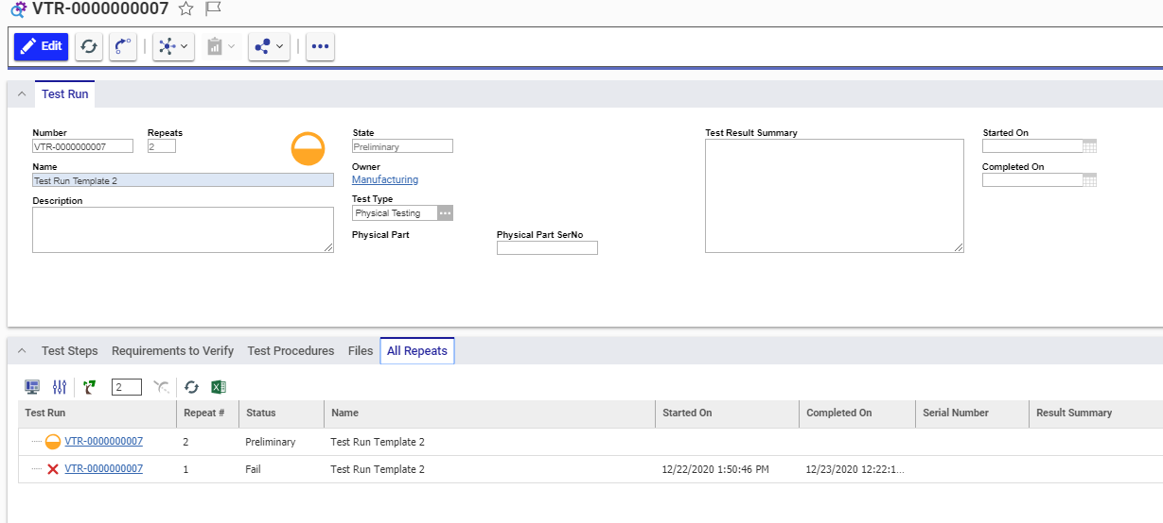

Connected to Requirements (optional install)

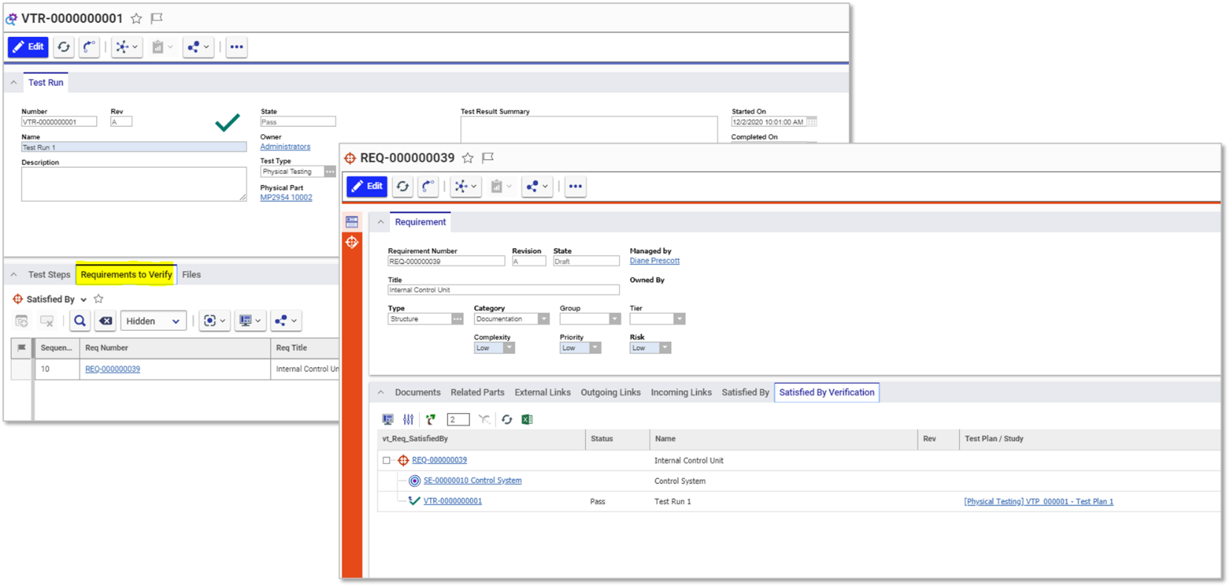

**Design Validation of Requirements – via Simulation or Tests on Engineering Parts (optional install)**

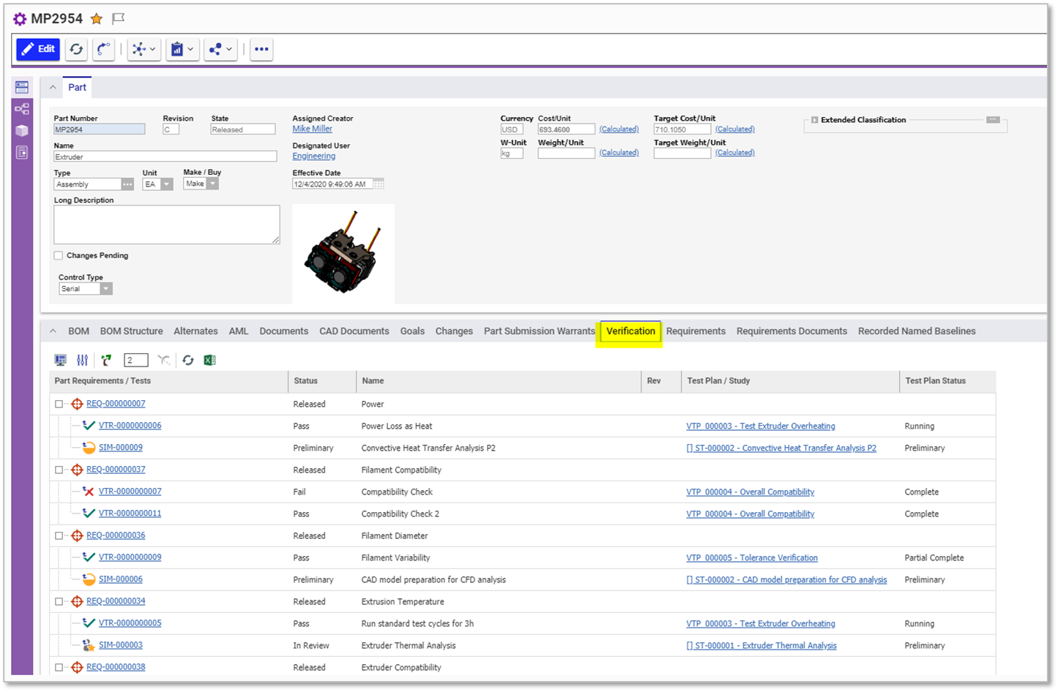

**Testing (Verification) History – On Physical Parts (optional install)**

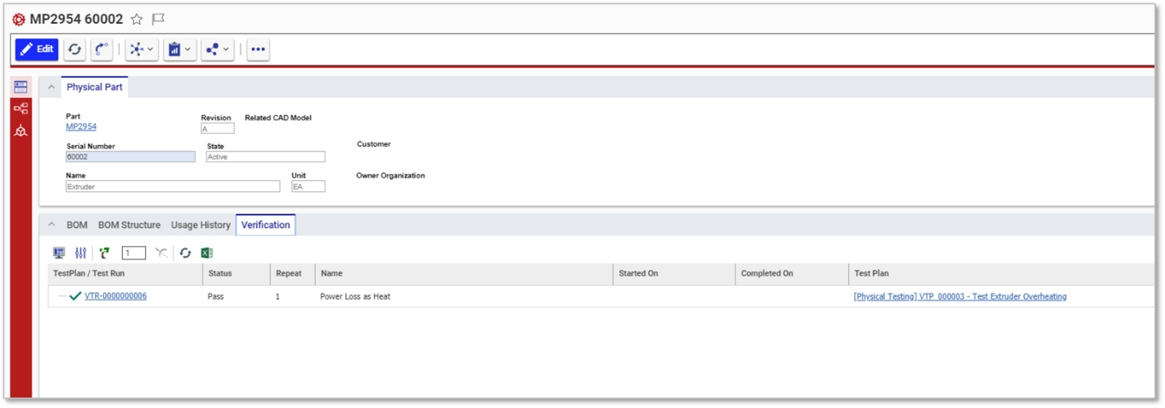

**Based on other Solutions**

(optional) RE, SA, SM

**Based on Innovator Platform Services**

Query Definitions; Tree Grid Views.

**Known Issues**

None documented, yet

**Improvements**

* Add repeat of Test Runs, if “Failed” .. (released status) create new version (generations are repeat count)
* xx

**Installation**

Please refer to README file.

**Implementation Approach**

See Implementation Approach document for more details. … TBD